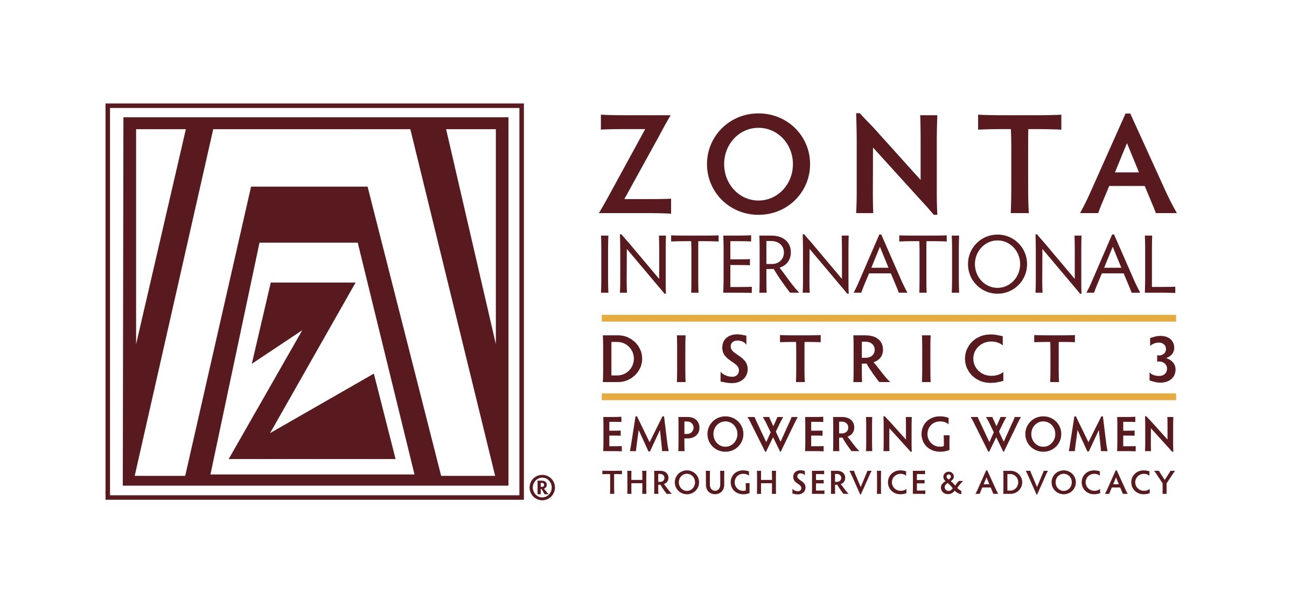

Public Relations Club Report Form 2017-2018

Club Name: __________________________________________________________________

Individual Completing Report: __________________________________________________

Preparer’s e-mail address: ______________________________________________________

Preparer’s telephone number: ___________________________________________________

District 3 Club Achievement Form 2017-2018

Public Relations and Communications Committee

Instructions:
Following the guidelines below, send your completed report form by mail or email, postmarked no later than 30 June 2018, to:

- D3 Public Relations Chair, Lisa Burton, lisaburton48@gmail.com, 257 Centre Avenue,
New Rochelle, NY
      - Governor Donna Clark, donna.clark1@verizon.net, 3335 Elsa Avenue, Waldorf,
MD 20603
- Area Director for your Club:
- A1 – Suzanne Scalcione, scal346@aol.com, 346 Littleworth Lane,
Sea Cliff, NY 11579
- A2 – Pamela Morgan, pemorgan@aol.com, 231 West 6th Avenue
Roselle, NJ 07203
- A3 – A3 – Jan Bryant, bryantj2104@verizon.net, 2104 Commodore Court, Odenton, MD 21113
- A4 – Carol Beechler, candlecrew04@yahoo.com, 10301 Amberleigh Court,
Manassas, VA 20110

Public Relations Overview

Zonta Public Relations communicates our mission of advancing the status of women worldwide to key publics in order to increase awareness, understanding, support and cooperation. Clubs are encouraged to use every opportunity to be creative in promoting the International Zonta message as well as local club accomplishments to the community. Promoting this awareness is accomplished by using all forms of media at both the International and local club level.

Report Guidelines

Complete a report on your club’s Public Relations activities from June 2016 to May 2017. It is suggested that you include information about the following (but not limited to this list) for your report:
- Newsletter
- Website
- Press Releases
- Brochures
- Promotional products
- Special Events and Fundraisers
- Audio Visual materials
- Zonta Rose Day
- Recognition and Awards
- Archiving

You may also attach sample copies.

Additional suggestions for report content. (Please note: your report should not be limited to the ideas below. Try not to base the sole content of your report by providing answers to any of or all of these suggestions. Be creative in your report. We are interested in how YOU express your accomplishments.)
Provide an overview of your club’s Public Relations activities. You might choose one or more events that best exemplify your club’s unique goals and objectives.

Have you developed and published a club newsletter? Please attach a copy.

Include key points in your report that support your goals and how they were accomplished, i.e., if your club has a new or improved brochure, website, newsletter or promotional product. In the report include what you did, how you did it, number of members involved, and outcomes.

Review how good usage of PR has increased new membership in your club.

Include information about club history (archives) and how this has generated interest in your club throughout your community.

Highlight how your local club has incorporated information about Zonta International’s goals, objectives and programs into your public relations plan.

Think about what has been the best usage of your club’s Public Relations Committee in terms of time and talent in creating an overall PR program for your club.

Tell us what you’ve done that’s new and exciting…and we want to hear your ideas for the future!

