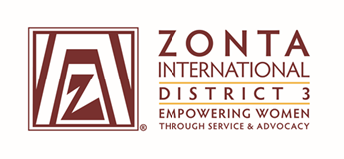

United Nations Committee Report

2017-2018

Club Name: ____________________________________________________________

Person Completing Report: _______________________________________________

Preparer’s e-mail address: ________________________________________________

Preparer’s telephone number: _____________________________________________

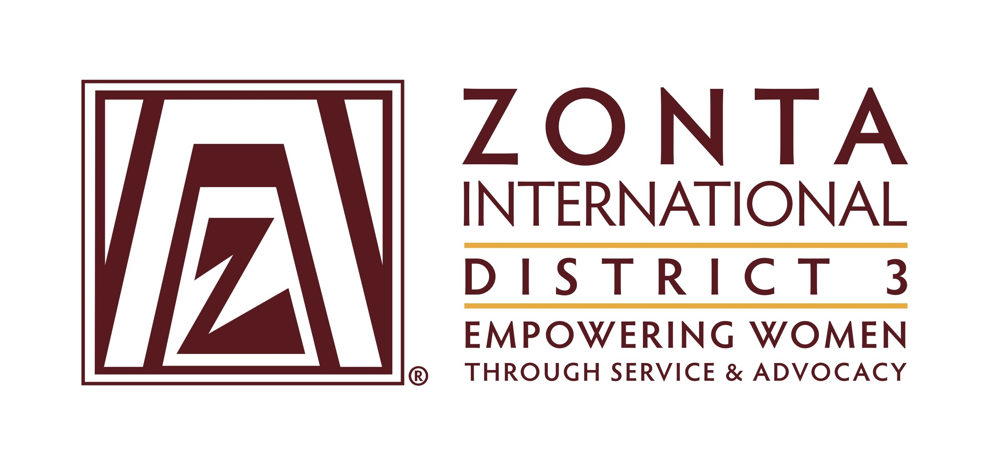
District 3 Club Achievement Form 2017-2018

United Nations Committee

Instructions:
Following the guidelines stated below, send your completed club report form, either by email or mail, postmarked no later than 30 June 2018, to:

- D3 UN Chair, Mary Ann Tarantula, marymac215@gmail.com, 1 Elder Ave, Bergenfield, NJ 07621
- Governor Donna Clark, donna.clark1@verizon.net, 3335 Elsa Avenue, Waldorf,
MD 20603
- Area Director for your Club:
- A1 – Suzanne Scalcione, scal346@aol.com, 346 Littleworth Lane,
Sea Cliff, NY 11579
- A2 – Pamela Morgan, pemorgan@aol.com, 231 West 6th Avenue
Roselle, NJ 07203
- A3 – A3 – Jan Bryant, bryantj2104@verizon.net, 2104 Commodore Court, Odenton, MD 21113
- A4 – Carol Beechler, candlecrew04@yahoo.com, 10301 Amberleigh Court,
Manassas, VA 20110

District Goals
- Increase awareness of Zonta International’s activities at the United Nations and how our international goals are furthered by ZI’s status as a non-governmental organization, including club-level training and education.
- Encourage club presidents to share international news from the Governor’s newsletter as well as information provided by area directors, the District 3 United Nations Committee Chair and ZI United Nations Committee Chair.
- Seek out opportunities to work with other clubs on UN projects, especially in the realm of advocacy – specifically on women’s issues that clubs are informed about.
- Advocate for the 16 Days of Activism, November 25th-December 10th
- Inform District and ZI United Nations chairs of club activities that highlight our UN partnership, and publicize them.
- Create programs and events within the clubs and communities that will engage members in support of Zonta’s association with UN projects and UN organizations such as UNICEF and UN Women. Publicize Zonta’s advocacy initiatives.
- Increase the visibility and credibility of Zonta as it pertains to international issues.

Report Guidelines

Complete a report on your club’s UN activities from June 2017 to May 2018. You should attach copies of publicity or any other pertinent information.

Your report should answer the following questions: (Reference your answers by indicating the question number)

1. Did your club observe UN Day or present a program highlighting UN themes or issues? Does your club have a UN chairman who keeps the club informed about international issues?

2. Did any of your club members attend the UN Event in New York in March 2017? If yes, did one of your members make a report about the event to the club membership? Did attendance at this event increase awareness of ZI and its partnership with the UN?

4. Did any of your club members attend other UN events? If so, please explain.

5. Has your club enlightened the community about Zonta International’s involvement with the UN? If so, how? Explain. Attach copies of your publicity.

6. Did your club take part in the 16 Days of Activism? Explain. If yes, did your club disseminate information to the public about this program?

7. Share any other information about your club and its involvement with international events/programs. (Keep in mind that if your club is involved in a service program in another country, it is considered to be a local service and should not be included for this report.)

